Connecting lines

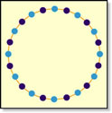

Twenty four dots are evenly spaced around a circle.
If every dot is joined to every other dot with a straight line, how many lines are there?

